**Lab 2: Measuring Electrical Signals with the Oscilloscope Part 2**

650:361 Introduction to Mechatronics

Team Members: Shivani Topiwala, Nancy Contreras, and Pamela Pajarillo

**Part B)**

For this section, we created a low pass filter by building an RC circuit. Our goal is to find the cut off frequency, so we first calculated the theoretical value using the equation $f_{c}=\frac{1}{2πRC}$. We then used the software to find the measured value. In order to do this, we had to isolate the period so that the all the values displayed were constant. In this interval, we only changed the frequency and observed the change in the amplitude of the wave. In order to find the cut off frequency, the amplitude had to be $\frac{1}{\sqrt{2}}$ or approximately 70.7% of the frequency.

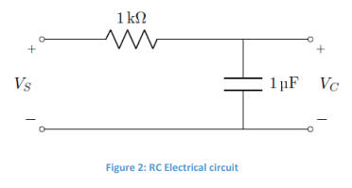

|  |  |
| --- | --- |
| **Calculated Value** | **Measured Value** |
| 159.1549 | 159.071 |

Table 4:Frequency of Low-pass Filter in Hz

**TASK 3: Led-Diode Circuit**

In this section, we had to build a LED-diode circuit using a LED light, a resistor, and wires. Our goal was to find the DC offset point of the diode, which is to say the point where the LED light turned off. After we completed the circuit, we used the software to send variable voltage. We then continually lowered the voltage until the light turned completely off, and recorded the voltage value. We repeated this procedure three times and calculated the average value.

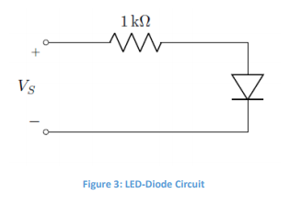

*Voff*= 1.47 V

**Conclusion**

For this lab, we used a new part of the software to control the current in the broad. Using this software, we were able to measure current, voltage, and resistance across three resistors. The software also gave us more information about the signal sine wave, such as amplitude and frequency. We also learned and applied the concept of cut off frequencies and low pass filters. In conclusion, this lab allowed us to practice measuring circuits using new resources and concepts.